**Team name:** Luna R

**Team member:** Xinghai Nian, Bingzhen Chen, Xiaoqian Yang

**Project title:** Flashcards to learn a foreign language

**Application Description:**

* **Describe what market space is the application related to:**

Our website is a web-based learning application designed to help users of all ages learn a new language through the use of flashcards and quizzes. The application is intended to be used by individuals, educational institutions, and corporate organizations. Our website falls into the educational technology market space. This market space comprises digital learning tools, learning management systems, and other educational software products that facilitate learning.

* **A list of features:**
* User Authentication and Account Management
* Learn by using Flashcards
* Notes Creation
* Take quiz
* Scoreboard
* **Functional specifications**
  + **General play description and outcomes**

Our website is designed to help users practice and improve their language skills in a fun and engaging way. The website offers a study mode and a variety of quiz modes, including multiple-choice, true/false, with questions on various language topics such as vocabulary, grammar, and cultural knowledge. Users can select their preferred language and mode to customize their learning experience.

Upon logging in, users can choose from a list of available languages and study or quiz modes, and then proceed to study using flashcards or answer the questions. In study mode, users can create their own notes for later reference; In quiz mode, the website provides immediate feedback on whether the user's answer is correct or not. At the end of each quiz, the user is given a score and the option to review scoreboard for all users’ score and rank or their own scores.

The ultimate outcome of using this website is for users to improve their language skills and gain confidence in their ability to communicate in the target language. With regular practice and use of the website, users can increase their vocabulary, grammar knowledge, and cultural understanding, and ultimately achieve their language learning goals.

* + **Feature sets with use case scenarios for each feature**

1. **User Authentication and Account Management:**

**Description:** This feature allows users to create an account if they do not already have one. Login requires users to provide their username and password before they can have access to certain features or information of our website.

**Use Case Scenario:**

A new user wants to create an account on our website to access the learning materials.

* User navigates to the website and clicks on the "Sign Up" button.
* User provides their name, email address, and password.
* User clicks on the "Create Account" button to complete the registration process.

A returned user needs to provide their correct username and password before they can have access to certain features or information of our website.

1. **Learn by using Flashcards**

**Description:** This feature allows users to learn a new language, including its vocabulary, grammar, and cultural knowledge using flashcards.

**Use Case Scenario:** A user wants to learn a new language. They navigate to the “choose language and mode” webpage and select the language and study mode. The system presents them with a list of flashcards for that language. The user selects a flashcard and reads the question/material on the front. They then flip the card over to reveal the answer/related knowledge.

1. **Notes Creation**

**Description:** This feature allows users to add notes based on their needs.

**Use case scenario:** The user can add their notes and click on the "add notes" button to create a new notebook for the chapter. They then can also create a new note. Once they have finished, they save the note and organize them in their notebook. They can access their notes at any time by clicking on the notebook.

1. **Take quiz**

**Description:** This feature allows users to take quizzes based on their desired language. The system tracks users' scores and dates of taking the quiz, and then displays them on a scoreboard.

**Use case scenario:** A user wants to test their knowledge of history. They navigate to the “choose language and mode” webpage and select the language and quiz mode. The system randomly select 10 questions from our question database, with 5 multiple-choice question and 5 true or false questions. After the users submit, the system record user’s score and give the correct answers. In the meantime, this score will be added to the scoreboard.

1. **Scoreboard**

**Description:** This feature displays users' scores on quizzes. Users can view their own scores as well as the whole ranking scoreboard.

**Use case scenario:** A user wants to see how they compare to other users on a quiz. They click on the "Scoreboard" tab and the system displays a list of all the users who have taken the quiz, sorted by score. The user can see their own score as well as the scores of other users.

* **Include UML notations, diagrams, etc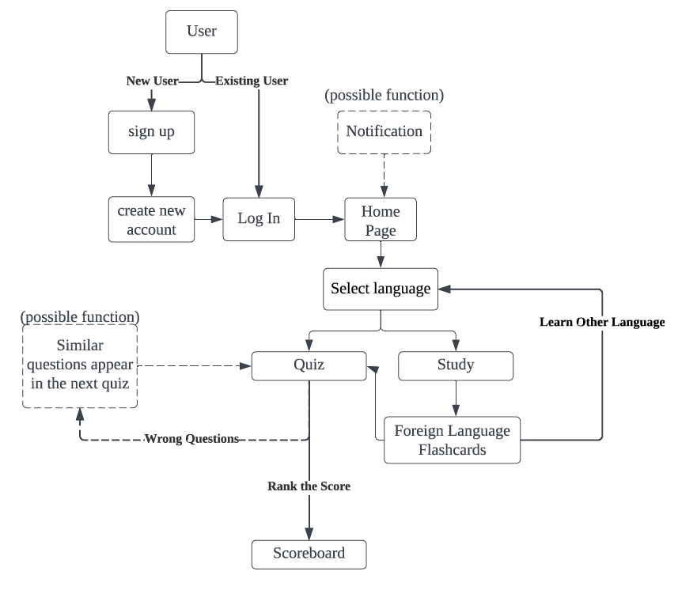**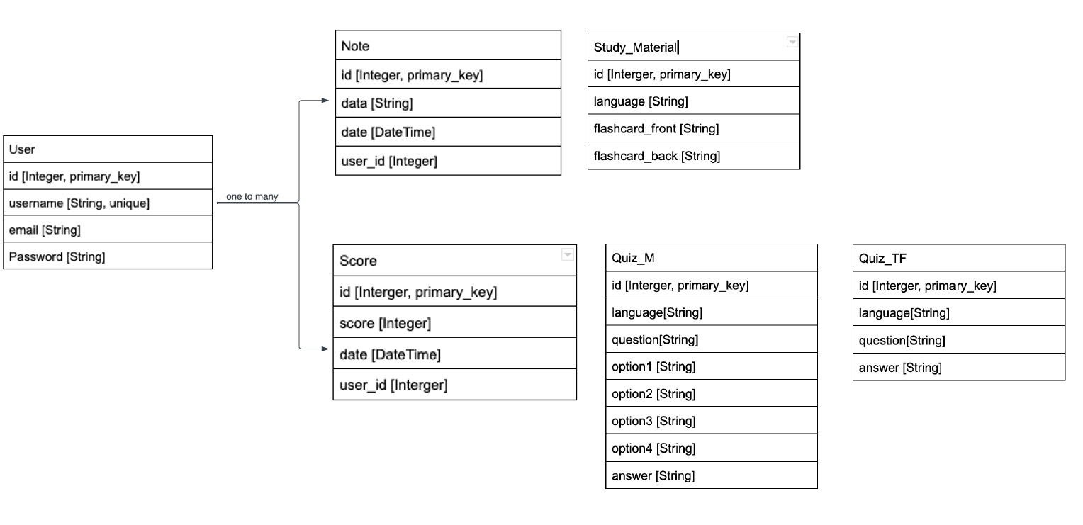
* **Testing plans for each feature**
  + User Authentication and Account Management
  + Learn by using Flashcards
  + Notes Creation
  + Take quiz
  + Scoreboard

For all above features will test as lists below:

* + Functionality testing:
    - Check that all the links on the website are working properly.
    - Verify that users can log in, sign up, and log out successfully.
    - Ensure that users are redirected to the correct pages after logging in or signing up.
    - Check that users are able to choose a language mode and access the quiz.
  + User interface testing:
    - Verify that the website is visually appealing and easy to navigate.
    - Check that all buttons and forms are properly labeled and functioning correctly.
    - Ensure that the website is responsive and looks good on different size of screens.
  + Security testing:
    - Check that user passwords are being stored securely (using a secure hashing algorithm).
  + Database testing:
    - Verify that user information is being stored correctly in the database.
    - Check that the database schema is designed properly and optimized for performance.
  + Performance testing:
    - Test the website's load times to ensure that it is loading quickly and efficiently.
    - Use JMeter to check that the website is able to handle a large number of users simultaneously without crashing or slowing down.
* **List of features that will be accomplished in the following (major) milestones M2, M3, M4 or M5.**
  + User Authentication and Account Management (M2)
  + Learn by using Flashcards (M3)
  + Notes Creation (M3)
  + Take quiz (M4)
  + Scoreboard (M5)